

Department of Computer Science Code:
CNS301
Course Title: Computer Networks

Spring 2026

Lab 04
Objective:
Implementing FTP, DHCP and DNS server in a wired network using packet tracer.

Student Information

Student Name | Saniya Khan
Student ID | 24SP-038-CS
Date
Assessment
Marks Obtained
Remarks
Signature
Lab 04: Implementing FTP , DNS and DHCP Server
Usman University
Department of Computer Science
CNS301 –Computer Networks
Lab 04

Instructions

- Come to the lab on time. Students who are late more than 20 minutes, will not be allowed to attend the lab.
- Students have to perform the examples and exercises by themselves.
- Lab work must be submitted on the same day it is performed.

1. Objective
Exploring the efficacy of DHCP and DNS server in a wired network using packet tracer.

2. Labs Descriptions i. File Transfer protocol
It is an application layer protocol which is utilized to send and receive files over the Network, it is communication between client and server. This communication takes place when a client requests connection to FTP server using ‘username’ and ‘password’, once legitimate credentials are produced by a client it gets connected to the server after successful connection the thing that matters is what rights a specific credential has. Below is a depiction of that.
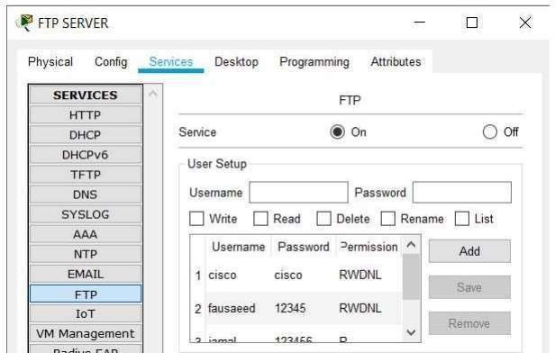
Figure1: Registering Credentials on FTP server

FTP can be used to backup the data which is an essential aspect, these days the biggest threat to data or any network is ransomware attack, and the best defense against it is proper retrieval of data. FTP went
Page 2 of
Lab 04: Implementing FTP , DNS and DHCP Server
through numerous revisions in its RFCs, the FTP client are used to download and upload data, one such client is Filezilla.

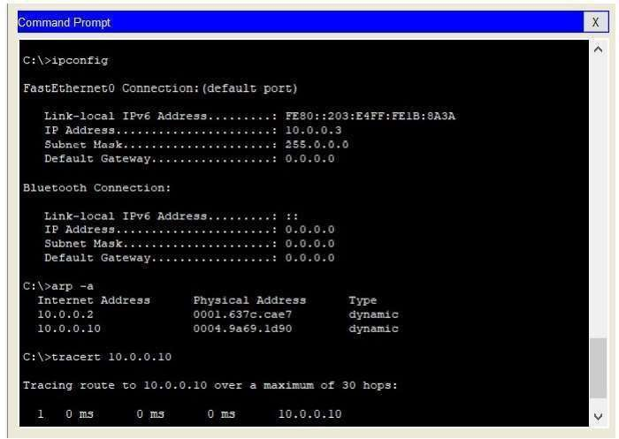
Figure2: Using Diagnostic commands in FTP Client-Server Network

FTP commonly uses port number 20 and 21 for connectionsthis particular concept is shown below where a node is contacting the FTP server for connection through port 21 and data connection is done using port 20 at the server and open port at the client end.
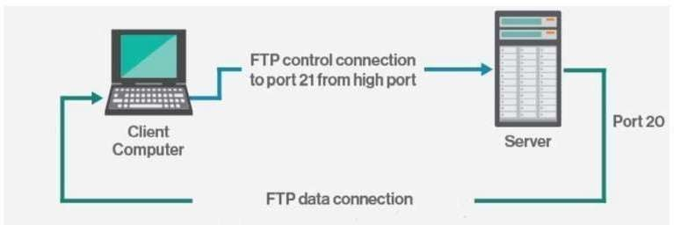

Figure 3: Client connecting to server utilizing port 21 and 20

Page 3 of

ii. DHCP
It stands for dynamic host configuration protocol, it is a network management protocol used mainly to distribute IP address to all connected devices in a network. when ever a system is turned on in a network it sends a request to server this request is called DHCP DISCOVER, on receiving the request it supplies the client with a IP address from its pool this offer is called DHCP OFFER, on receiving the offer the client responds with the packet called DHCP REQUEST to eventually get the IP.

- Select 3 PCs and a server from “End Devices” your work area will look like this.

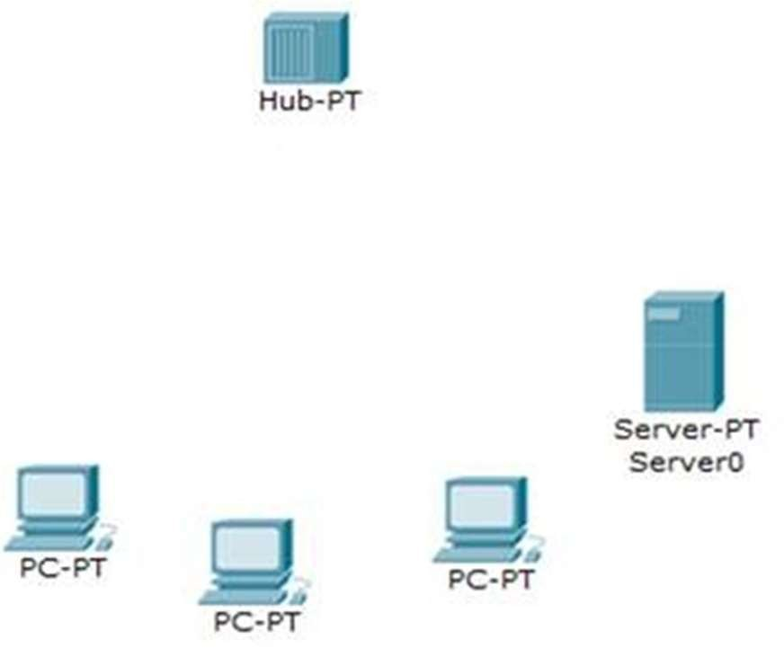
Figure 4: selecting devices and placing them on the work plane.
- Choose “Connection Type” to connect these devices with HUB.
- Now click on all three PCs
- Go to “DESKTOP”
- Then “IP CONFIGURATION”
- Here select option “DHCP” instead of assigning IP Address Statically
- Now click the Server

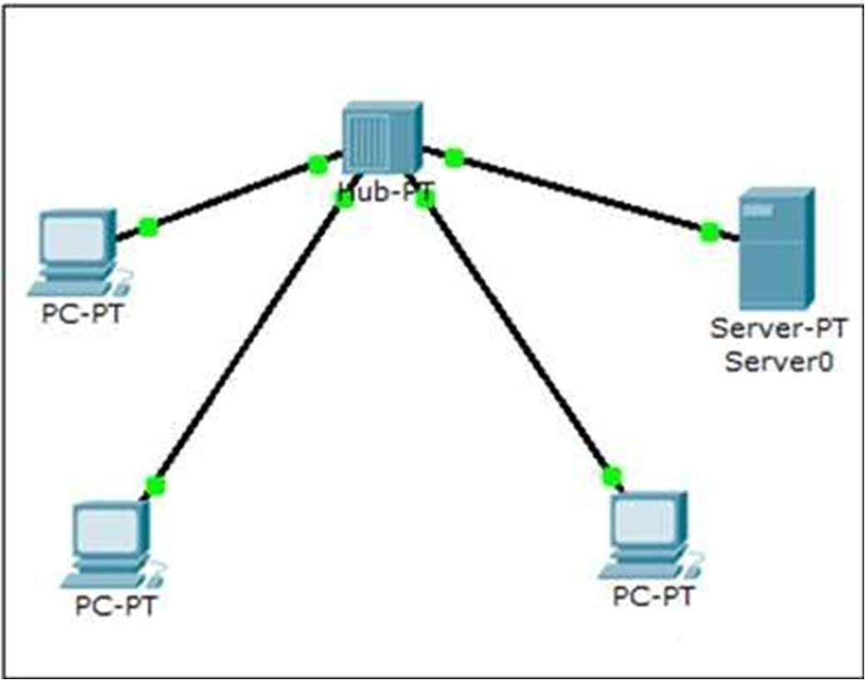
Figure 5: Connecting the server and systems together via HUB.

- The screen you will see will look some thing like this:

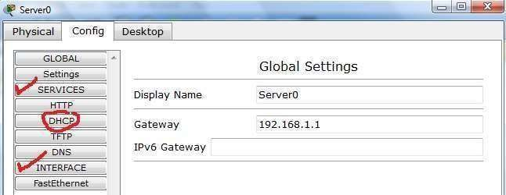

Figure 6: Depicting DHCP Server settings

- Above diagram shows the screen which you will see on clicking “SERVER” Machine.
- Here go to Fast Ethernet placed just under Interface marked with red.
- After clicking “Fast Ethernet” you will see following window. Here assign IP ADDRESS to this SERVER.

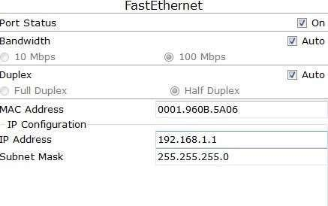
Figure 7: Setting IP Address
L) Now click “DHCP” to make this server a DHCP server.

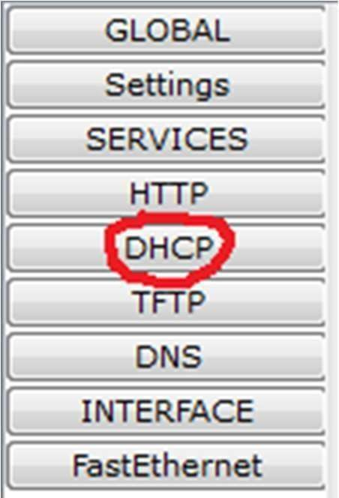
Figure 8: Selecting DHCP as Server

- DHCP is “Dynamic Host Configuration Protocol” a DHCP server is responsible for Assigning IP Addresses to the devices present in the Network from its pool. This Concept can be seen in the image shown below.

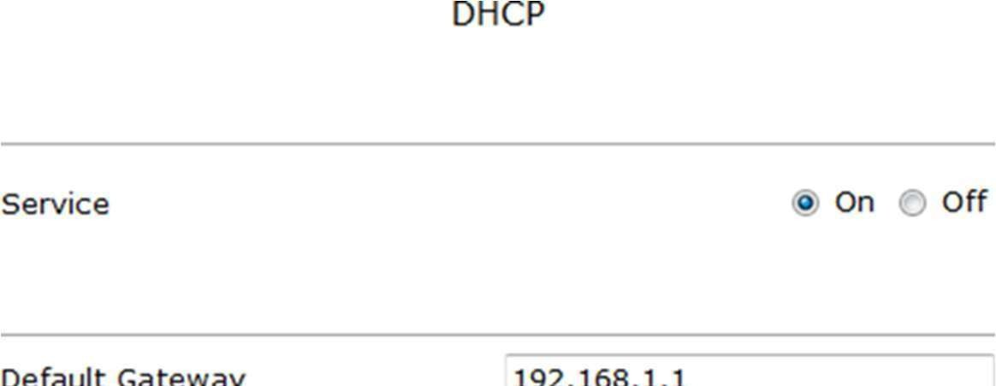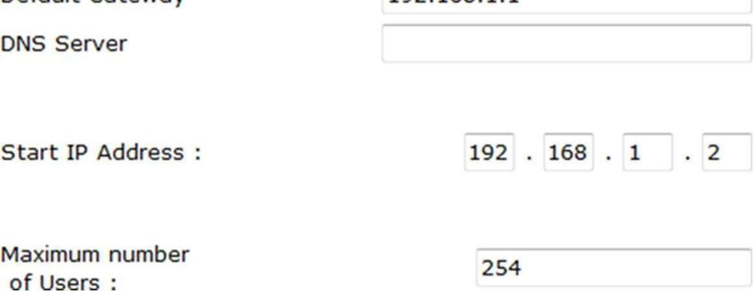
Figure 9: Turning DHCP Server ‘on’

- now each device will take IP from DHCP

iii. DNS
DNS is” Domain Name Services” server the main purpose of this server is to resolve domain name against its allocated IP address. Humans can recognize a name that’s why we give names to web sites or locations in networks but actual destination is located through IP address which is a sequence of numbers and is very difficult for an individual to remember.

example: It is easy to remember www.yahoo.com then 87.248.113.14

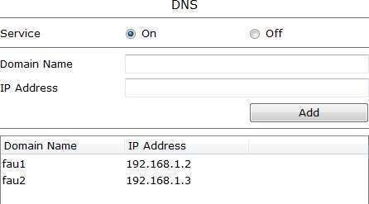
Figure 10: Turning DNS ‘on’ and defining name translation.
GO TO “FAST ETHERNET” of DNS and assign this server IP address 192.168.1.8

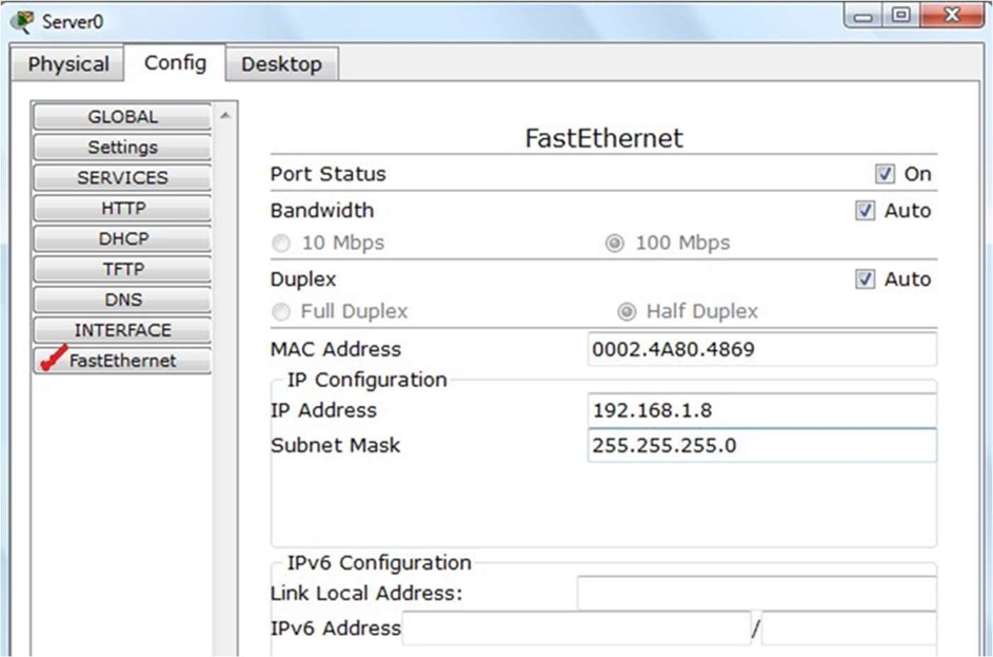
Figure 11: Setting IP Address

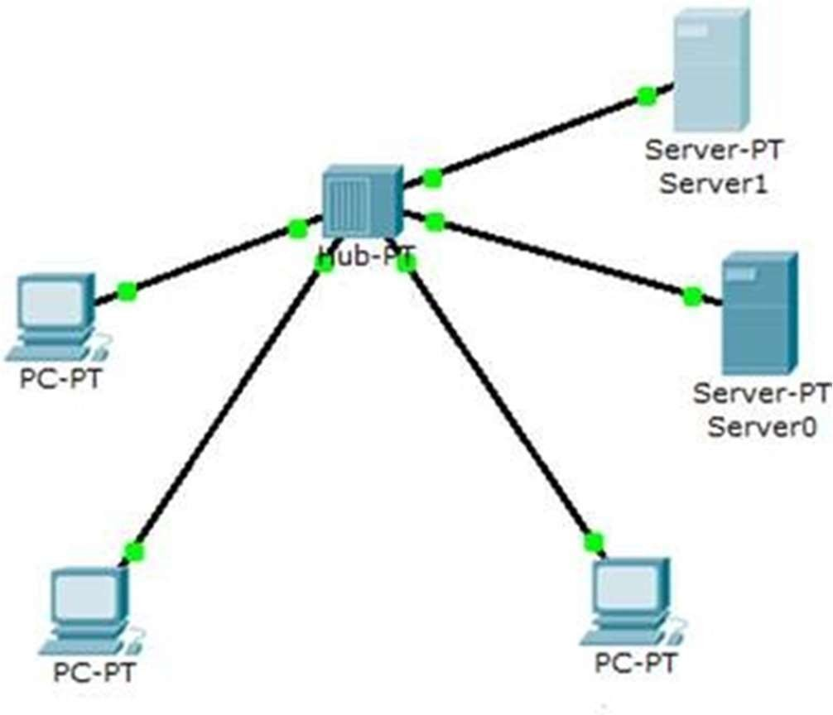
Figure 12: Network Topology now consist of DHCP and DNS both.

- Mention this IP Address of DNS at DHCP server as well. Look at the previous screen shot where we have discussed DHCP server there the slot of DNS server is empty, because we have no DNS server in our network but once you will introduce a DNS server you will have to give its Address at DHCP server.
- Now after creating DNS server the DNS Packets should also travel successfully

Lab tasks

- Implement the following scenario using packet tracer, create FTP server and two nodes a user can login using any of these systems.

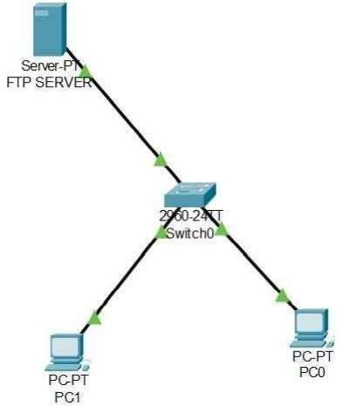

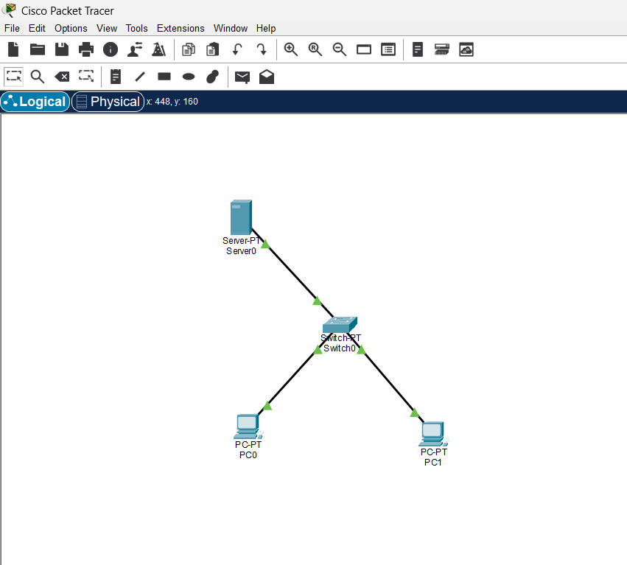

- Create DHCP and DNS server and explain its efficacy.
